CS 255 System Design Document Template

This template lays out all the different sections that you need to complete for Project Two. Each section has guidance to prompt your thinking. You will need to continually reference the interview transcript as you work to make sure that you are addressing your client’s needs. There is no required length for the final document. Instead the goal is to complete each section based on what your client’s needs are. Remove this note when you are finished, and replace all bracketed text with the relevant information.

UML Diagrams

UML Use Case Diagram
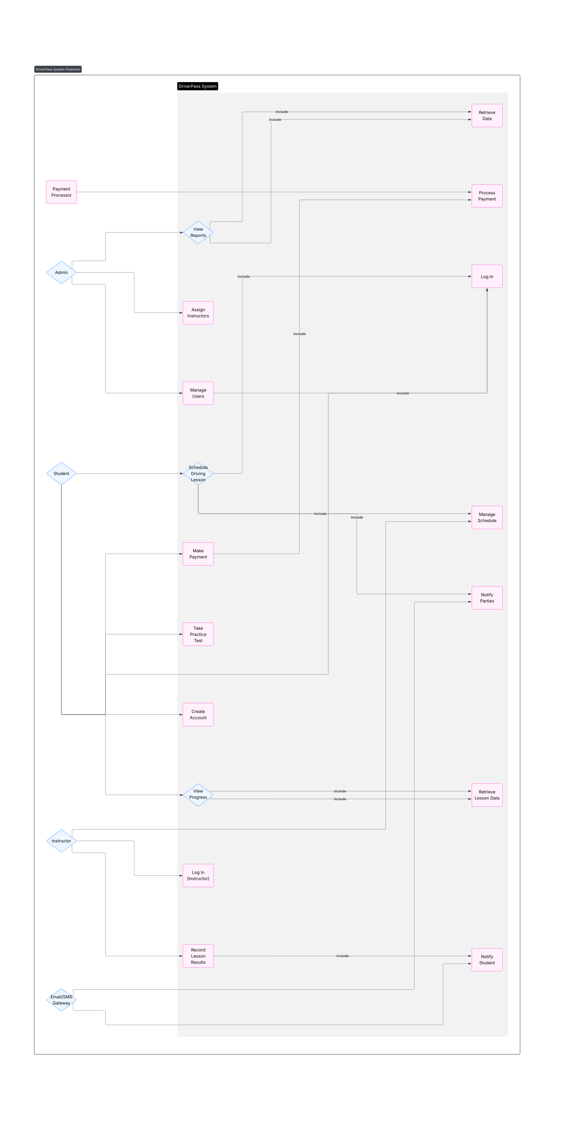

UML Activity Diagrams
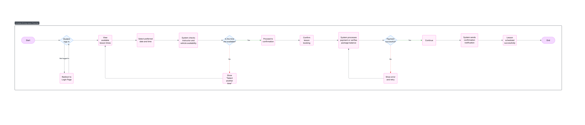
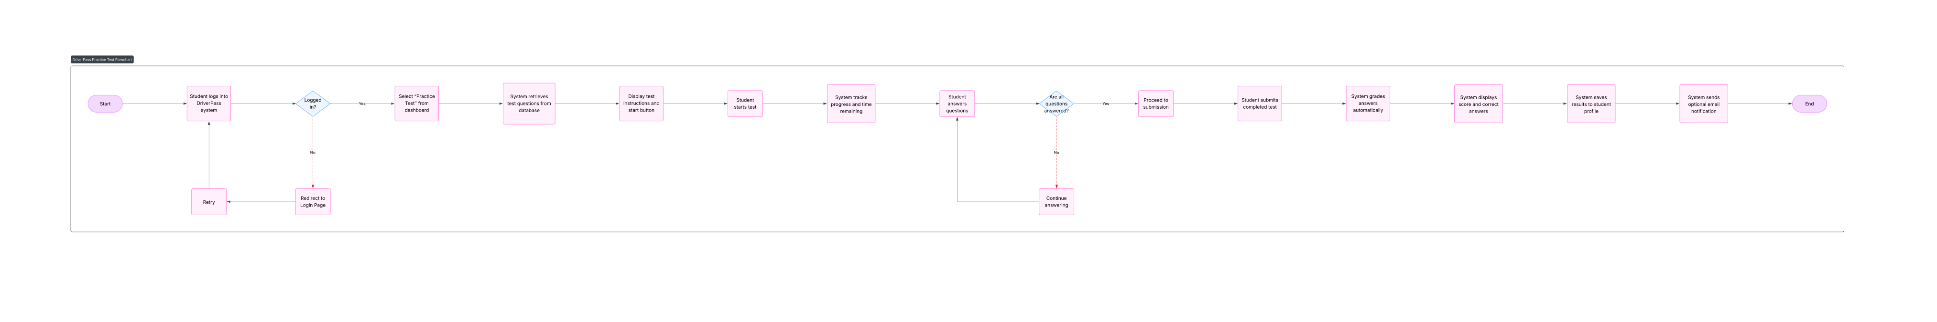

UML Sequence Diagram
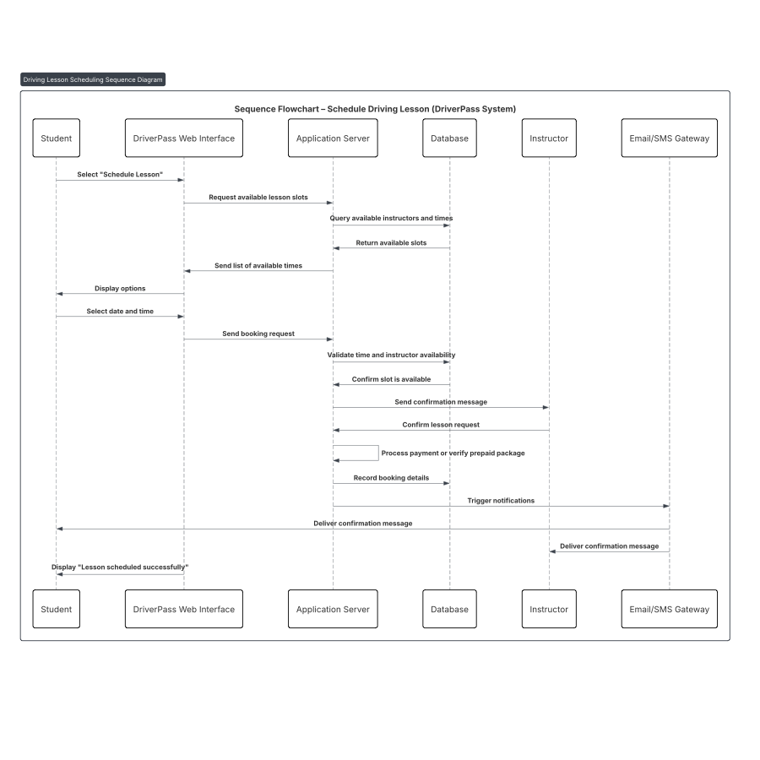

UML Class Diagram
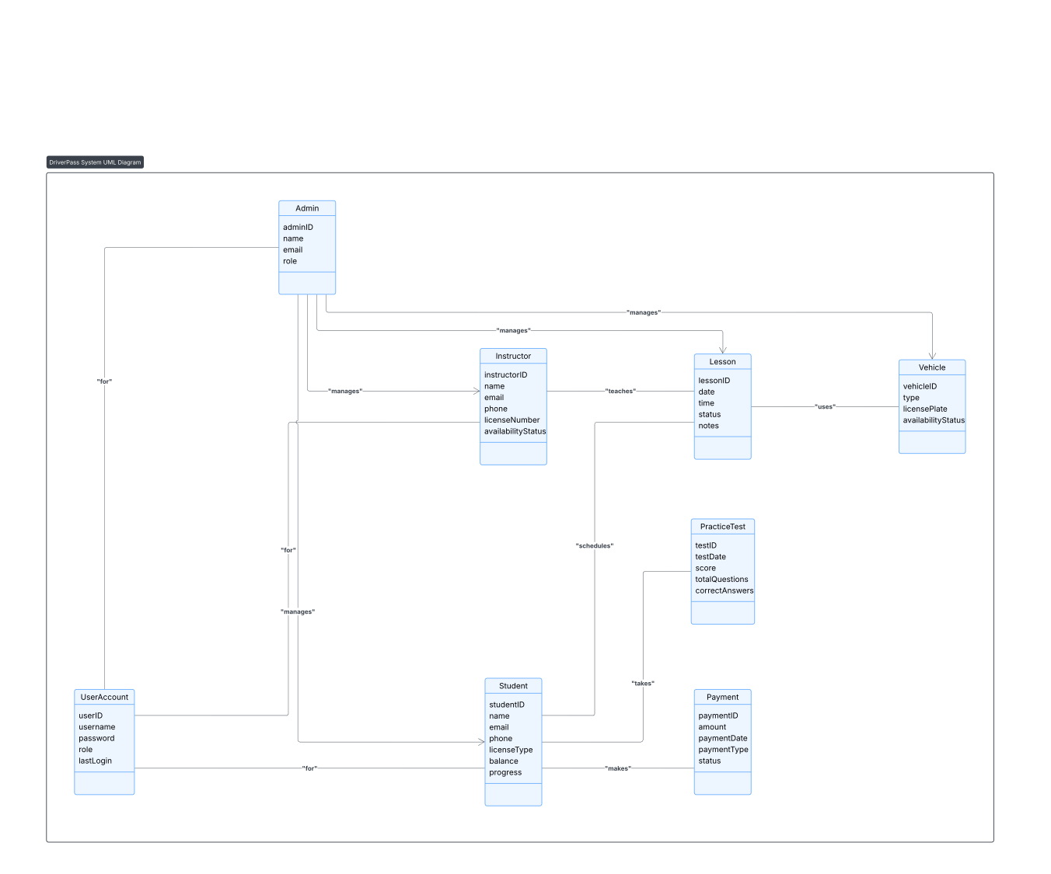

Technical Requirements
The system will run as a secure, cloud-hosted web application that includes the front end, the backend, and a relational database to store the information. Required infrastructure includes cloud app hosting, a managed SQL database, object storage, and a notification service. There will also be an integration for third-party payment processing. The system should have backups and securely store the data. The front end should use a modern web framework, and there should be a mainstream backend framework that allows for APIs to connect to other systems. There should be role-based access control that ensures each user only sees what is relevant and is within their scope to maintain data privacy. Lucid chart will also be necessary to develop charts that will help visualize the requirements. There should also be an application for project/issue tracking. With each of these tools, the team will be able to build out the DriverPass system according to the requirements outlined by the stakeholders.

